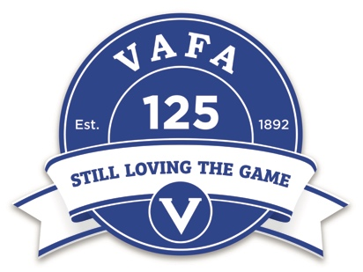

VAFA WILSON WOMEN’S PRE-SEASON LIGHTNING PREMIERSHIP

SATURDAY 1st APRIL 2017

ROUND | TIME | SPORTSCOVER ARENA | ELSTERNWICK PARK OVAL 1
1 | 9:00am | South Melbourne Districts v Caulfield Gram. | Collegians v Ivanhoe AFC
 | 9:40am | St Bedes/Mentone Tigers v Old Geelong | Old Camberwell Grammarians v Oakleigh AFC
 | 10:20am | De La Salle OC v Hampton Rovers AFC | Swinburne Uni AFC v Old Haileybury
2 | 11:00am | Oakleigh AFC v Ivanhoe AFC | South Melbourne Districts v Collegians
 | 11:40am | De La Salle OC v St Bedes/Mentone Tigers | Hampton Rovers AFC v Old Geelong
 | 12:20pm | Old Camberwell Grammarians v Swinburne Uni AFC | Caulfield Grammarians v Old Haileybury
3 | 1:00pm | South Melbourne Districts v Ivanhoe AFC | De La Salle OC v Old Geelong
 | 1:40pm | Caulfield Grammarians v Collegians | Hampton Rovers AFC v St Bedes/Mentone Tigers
 | 2:20pm | Old Camberwell Grammarians v Old Haileybury | Oakleigh AFC v Swinburne Uni AFC
GRAND FINAL | 3:00pm | Top two teams determined by highest points and percentage compete in the Grand Final

Matches will consist of:
- 2 x 15 minute halves with no time on and a 5 minute half time interval
- 5 Minute break between rounds
- 2 VAFA Umpires will be supplied by the VAFA per match
- 18 players per team on the field and an unlimited bench

